# FRONT – PAGE:

Name: NGUYEN NGUYEN VU

REGISTERED NUMBER: 001392807

DEPARTMENT: Computing & Mathematical Sci.

COURSEWORK NAME: COMP1787 REQUIREMENT MANAGEMENT

SUBMISSION DATE:

EMAIL ID: [nv4047m@gre.ac.uk](mailto:nv4047m@gre.ac.uk)

# Requirement Management Report for the case study: “Green Groceries Online Platform”

GG – Green Groceries

# SECTION – A: 1000 words at least.

1. INTRODUCTION ABOUT GREEN GROCERIES ONLINE PLATFORM:

Just one paragraph is enough (around 300-600 words) – could do at home and DO NOT SHARE TO ANYONE:

Green Groceries (GG) is an revolutionary online platform that delivers fresh, organic, and locally sourced groceries directly to customers.With the advanced technology, GG hopes to bridge the gap between rural farmers and urban consumers, providing access to healthy, sustainable, and environmentally friendly food choices. This initiave demonstrates a dedication to environmental and community health by pushing the boundaries of how sustainable products are distributed. To overcome the constraints of the traditional “Waterfall” approach to software development, Green Groceries chose to cooperate with System Concepts (SC), using the Agile and SCRUM techniques for a more adaptable and iterative development process. This choice was made in response to previous setbacks that demonstrated the need for a more adaptable and iterative approach to development. System Concepts (SC), a company selected for its expertise in Agile and SCRUM processes, is a vital partner in turning the GG vision into a concrete, user-friendly platform that can change in response to changing market demands and technological breakthroughs. The digital endeavor of Green Groceries is supported by a group of committed individuals, each of whom contributes their own specialization and perspective to the undertaking. This team effort embodies the spirit of collaboration and shared purpose, from the visionary CEO and Founder to the meticulous Financial Controller, the agile and experienced Operations Manager, the decisive Chief Accountant, the strategic Logistics Manager, and the creative Marketing Manager. Despite their different positions, they all work toward the same objective, which is to provide a platform that is both ecologically responsible and efficient so that a larger audience may adopt sustainable living. GG's internet platform has more value than only its short-term business goals. It signifies a change in the way customers access and use sustainable products, promoting more thoughtful and conscientious shopping choices. By emphasizing local sourcing, GG lowers the carbon impact connected with long-distance freight transit while simultaneously boosting the local economy. Additionally, the website acts as a teaching tool, educating a wider audience about the advantages of sustainable techniques and organic farming.

2. DRAWBACKS OF TRADITIONAL SOFTWARE DEVELOPMENT METHOD:

Show some practical examples in real world (you could use from the teacher suggested website – with screen shots that related to the website of using old SDLC methodology – or any others website you want that relate to the scenario with Green Groceries).

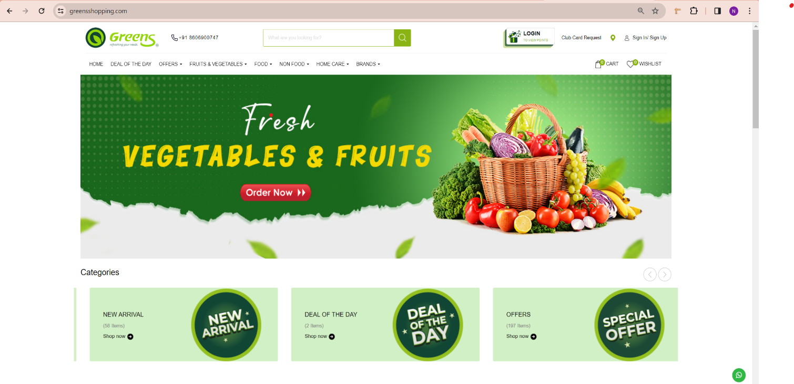

**Figure 1. Traditional website using Waterfall**

The <https://greensshopping.com/> website is one of the websites that applied Waterfall model to develop. As we can see, there are some disadvantages of applying traditional software development methods (like Waterfall) to develop web application:

Inflexibility in Handling Changes: For example, if <https://greensshopping.com/> website wanted to add a real-time inventory update system to their platform after completing the design phase using a Waterfall approach, the inflexibility of the model would result in delays and increased costs.

Long Time To Market: A website similar to <https://greensshopping.com/> may want to launch an online marketplace on a tight timeline. However, the Waterfall method's subsequent phases, in which testing occurs after the development phase, may extend the project's timeline. Competitors who use more agile strategies may launch sooner, seizing market share.

High Risk and Uncerntainly: If <https://greensshopping.com/> site used the Waterfall model to create a big platform feature, such as a supplier bidding system, any conflict with user demands identified during testing would necessitate a significant redo of past work. This late awareness raises project risk and perhaps wastes resources.

Limited User Feedback Integration: An online platform that decides halfway through development to update its user interface based on preliminary customer input may struggle to implement these changes easily in a Waterfall methodology. The absence of iterative development and early testing phases results in missed possibilities for early corrections based on user feedback.

3. AGILE FRAMEWORK METHODS AND ITS OVERVIEW:

Reference: slide file 4, 5, 6.

Introduce RAD, prototyping, JAD, Fiedlity Workshops, and Timeboxing.

4. SYSTEMATIC WORKFLOW OF ONLINE PLATFORM DONE WITH AGILE METHOD:

This part for choosing methods from overviewing all SDLC methodologies in the third part that we have overviewed. => applied the methods into the scenario.

(ARCHITECTURE DIAGRAM ABOUT GREEN GROCERIES ONLINE PLATFORM, SPRINT FLOW METHODS, STRUCTURE OF THE DEVELOPMENT TEAM AND THEIR ROLS, MODULE WISE DFD SUMMARY) => draw diagram through the tool inside the Word (you could draw in the draw.io but be careful of the overall size of the Word document.

Agile is all the methods would be evolved to support for Agile project.

5. MERITS OF USING AGILE:

List some advantages of using agile don’t write too much.

# SECTION – B: High level requirements analysis using MoSCoW rules

GG personnel mentioned in the course work you could… (ask teacher for more information)

1. BASE LINE REQUIREMENTS REVIEW

1.1. GIVEN REQUIREMENT ANALYSIS USING MOSCOW RULES:

|  |  |  |  |
| --- | --- | --- | --- |
| **ID** | **Requirements** | **MoSCoW rule applied** | **Reasons** |
| **1** | As an Order Handling Clerk, I want to use the website to process telephone purchases, replacing the paper-based system. |  |  |
| **2** | Maintain at least 20 office plants as part of the company's commitment to a green and healthy workspace. |  |  |
| **3** | As a customer, I want to be able to change my account details to ensure my most up-to-date information is recorded. |  |  |
| **4** | Organize a virtual celebration on the website for the CEO's birthday to showcase the company's fun and friendly culture. |  |  |
| **5** | As the Managing Director I want to be ensured that the site is Data Protection Act safe so that we do not get fined hundreds of thousands of pounds. |  |  |
| **6** | As a customer register an account. |  |  |
| **7** | As a Customer I want a choice of delivery slots so that I can arrange my diary appropriately. |  |  |
| **8** | As a customer, I want to be able to modify my shopping cart so that I can change my mind about what I want to buy. |  |  |
| **9** | The company should adopt pet-friendly policies to create a positive and inclusive work environment. |  |  |
| **10** | The system must be designed to handle a 30% increase in traffic during peak periods without degradation in performance. |  |  |
| **11** | As a customer, I want to enter separate delivery and invoice addresses so that I can receive bags when staying at a friend’s house. |  |  |
| **12** | As a Customer I want to be able to change my account details so that my most up to date details are recorded. |  |  |
| **13** | As an Order Handling Clerk I want to use the Web site to process telephone purchases so that I can stop using the paper-based system. |  |  |
| **14** | As a customer, I want to choose whether or not I am sent marketing information to avoid receiving excessive junk mail. |  |  |
| **15** | All user data, including personal information and payment details, must be encrypted to ensure the highest level of security. |  |  |
| **16** | Maintain consistent branding elements and design across the website to reinforce their brand identity. |  |  |
| **17** | The development team should participate in a team-building event every quarter to foster collaboration and a positive work environment. |  |  |
| **18** | As the Marketing Director I would like an offers or discount page so that we can inform our customers of the aforementioned. |  |  |
| **19** | As the Chief Accountant I want to the Web site to adhere to legislation regarding VAT so we are not hit with a hefty fine. |  |  |
| **20** | As the Operations Director, I want to accept all forms of payment to capture the largest market possible. |  |  |

1.2. UPDATED HIGH LEVEL FUNCTIONAL REQUIREMENTS

|  |  |  |
| --- | --- | --- |
| ID | HIGHER LEVEL FUNCTIONAL REQUIREMENTS | JUSTIFICATIONS/ RECOMMENDATIONS |
|  |  |  |
|  |  |  |

Only from 8 – 10 justification and/ or modification from the previous requirements MoSCoW table and/ or adding new functional requirements not from the previous table with reasons (recommendations)

2. TIMEBOX RULES FOR THE UPDATED HIGH-LEVEL REQUIREMENTS:

2.1. PRIORITISATION LIST OF REQUIREMENTS

|  |  |  |  |
| --- | --- | --- | --- |
| ID | Updated high level requirements | Priority level (High/ Moderate/ Low) | Time scale |
|  |  |  |  |
|  |  |  |  |

Copy and paste from the updated table with higher level requirements (maximum 10 updated requirements)

Maximum timebox from all of the time scale is 90 days for RAD development with all 10 new updated requirements.

2.2. EXPLANATION ABOUT PRIORITISING THE REQUIREMENTS AND THE DECISIONS TAKEN

Write in a paragraph around 500-750 words for all total in 10 new requirements; no need to write in each requirements.